Technical Design Document

Project name: **Dpay Wallet**

Prepared By: **Dhiraj Patil ( 46022702 )**

**Introduction:**

**Dpay Wallet** is created to meet the needs of online payment system. The user will able to perform wallet operations online. The different functional requirements in the project are as follows:

**Functional Requirements:**

* **Login/Register:**

A user will be required to log in into the application in order to perform wallet operations. If he/she has no account, they have to register by providing their name, their contact number, email ID, age, gender, password, etc.

* **Add Money:**

For making the payment the user need to add money in the wallet. The money can be added by using deposit service. You can add maximum of Rs. 10000 at a time and minimum Re. 1.

* **Withdraw Money:**

A user will be able to withdraw money from the wallet. A user can withdraw maximum Rs.10000 at a time. The money can be withdrawn if available in the wallet. You can withdraw money less than or equal to available balance. You need to provide password while withdrawing money to ensure that, you are right person/account holder.

* **Money Transfer:**

A user can transfer money to another user of the wallet. A user can transfer maximum Rs.10000 at a time. The money can be transferred if available in the wallet. You can transfer money less than or equal to available balance. You need to provide mobile number of other person to whom money will be transferred. You need to provide password while transferring money to ensure that, you are right person/account holder.

* **Check Balance:**

A user can be able to check available balance in the wallet after logging in.

* **Print Transactions:**

The recent transactions of a particular user can be seen by the user. Transactions contain the deposit, withdraw and transfer records of the particular user. It should also show the date and time when occurred.

* **Edit Profile:**

The user can be able edit his/her profile whenever wants. The mobile number and email id should not be changed. He/she can change the password if needed.

* **Forgot Password:**

A user will be able to recover his password if forgotten by providing the correct security question and its answer.

**Wallet Services:**

* **Registration:** Register a new user for wallet.
* **Login:** Login as a customer in wallet.
* **Deposit Money:** Add money in the wallet.
* **Withdraw Money:** Withdraw money from the wallet.
* **Transfer Money:** Transfer money from wallet to the other customer of the wallet.
* **Check Balance:** Check available balance in the wallet.
* **Print Transactions:** See the recent transactions done from the wallet
* **Edit Profile:** Edit profile such as name, age, etc.
* **Logout**: Logout from the wallet if logged in.

**Architecture Diagram:**

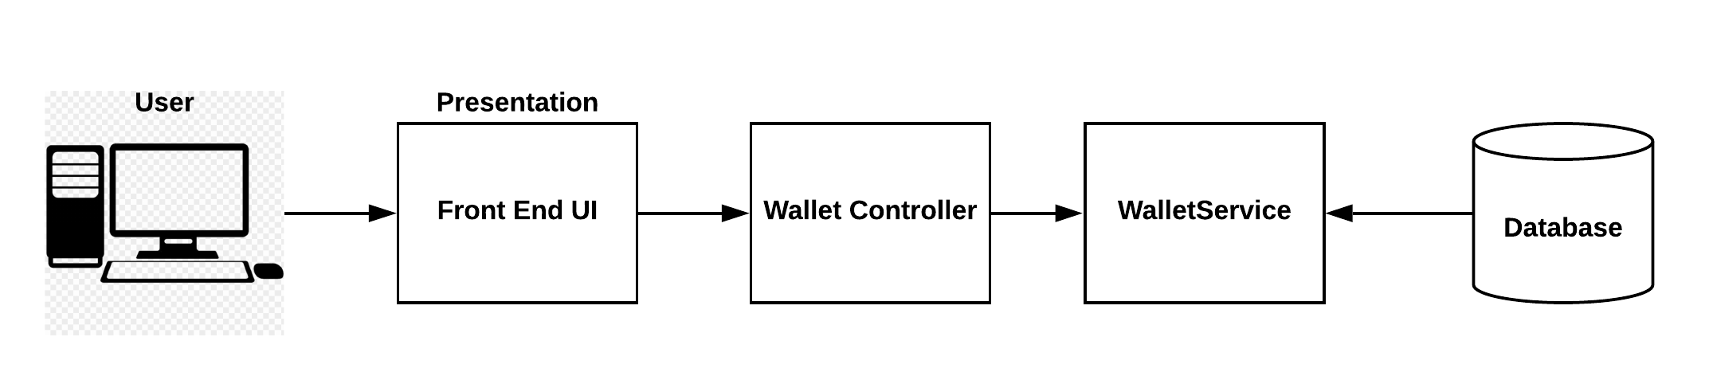

**Entity Relationship Diagram:**

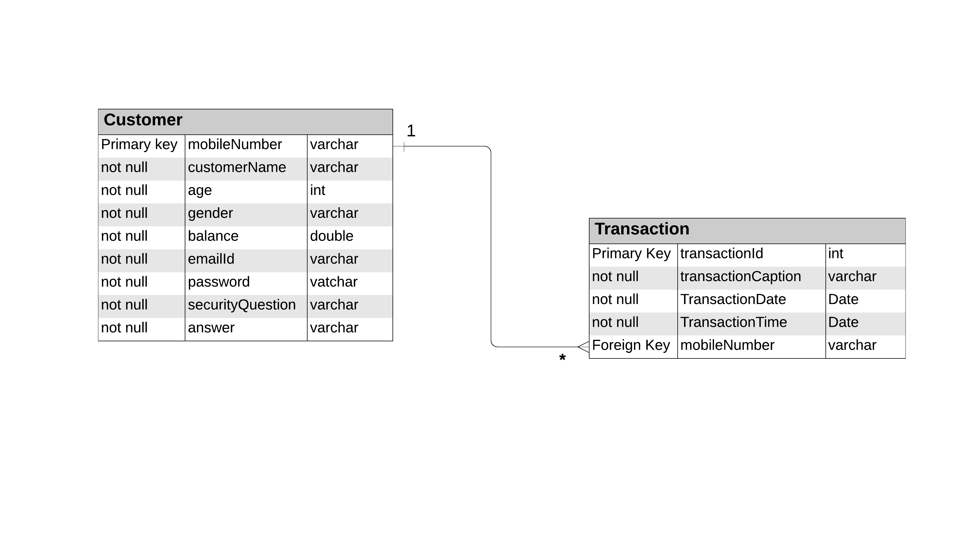

**Class Diagram:**

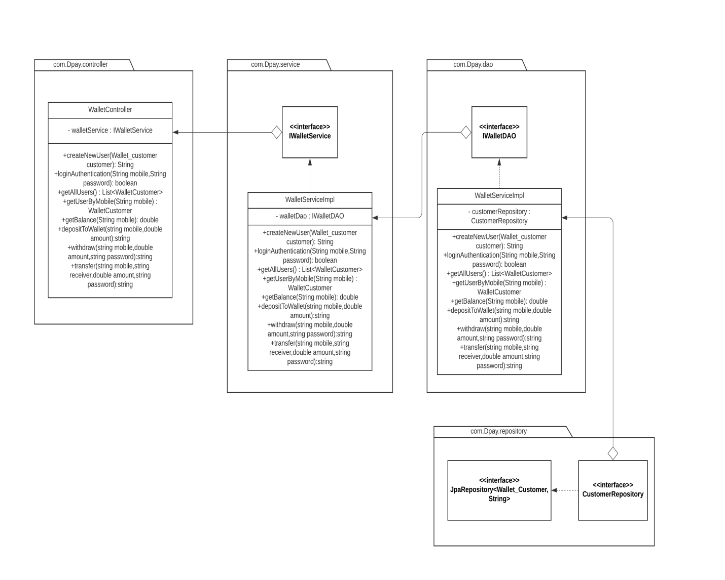

**Activity Diagrams:**

**Registration:**

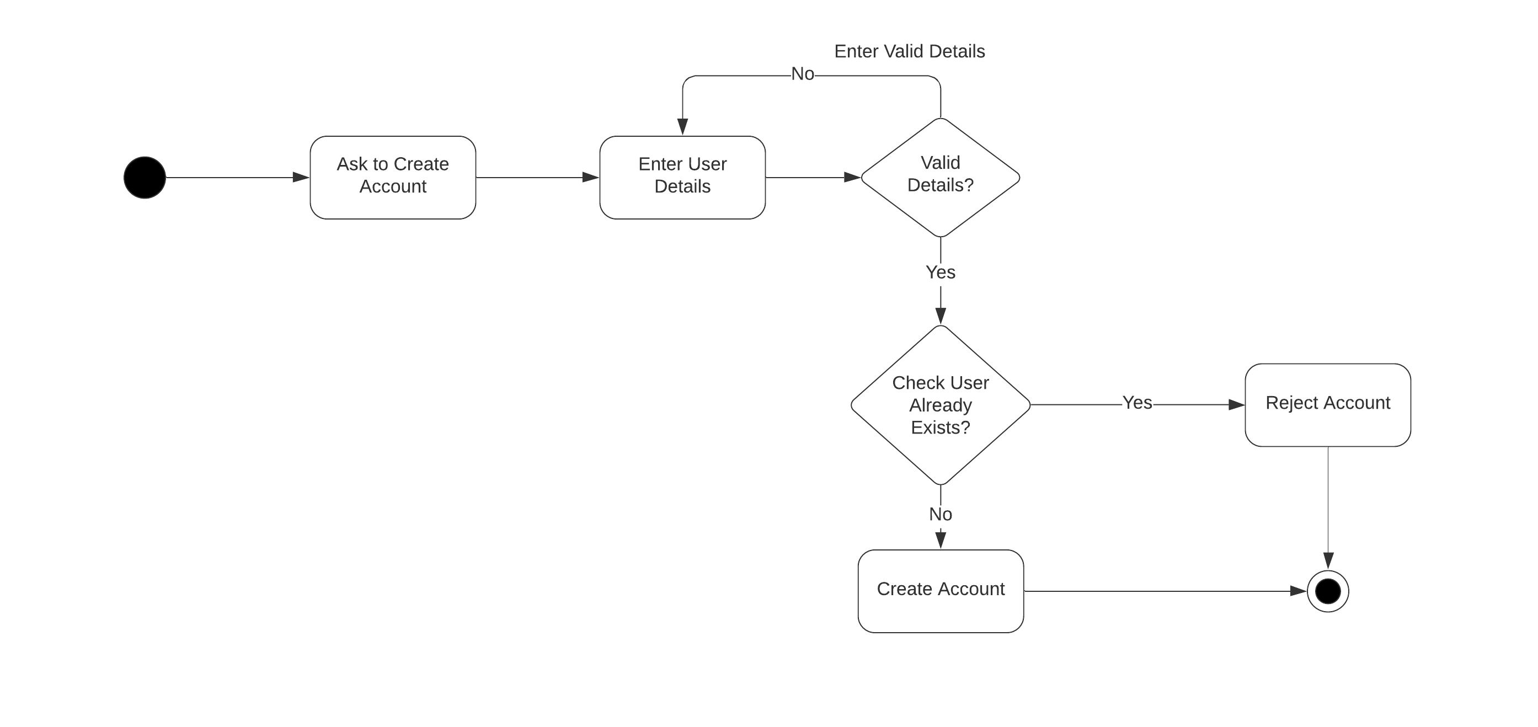

**Login:**

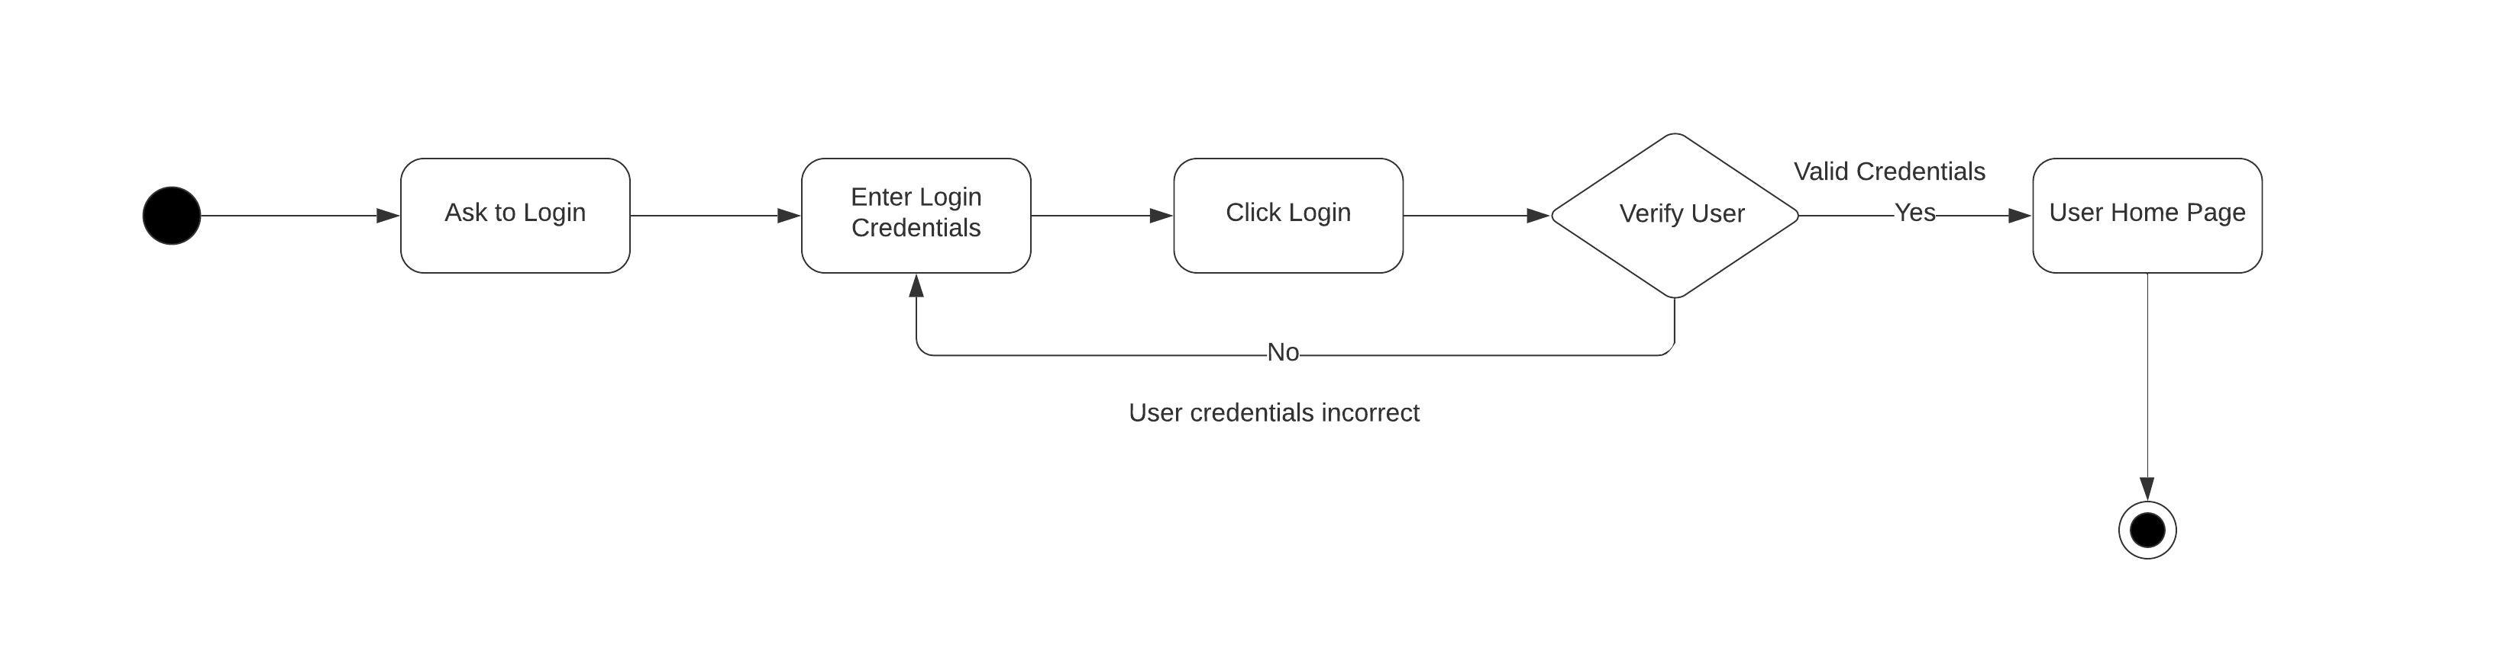

**Deposit Money:**

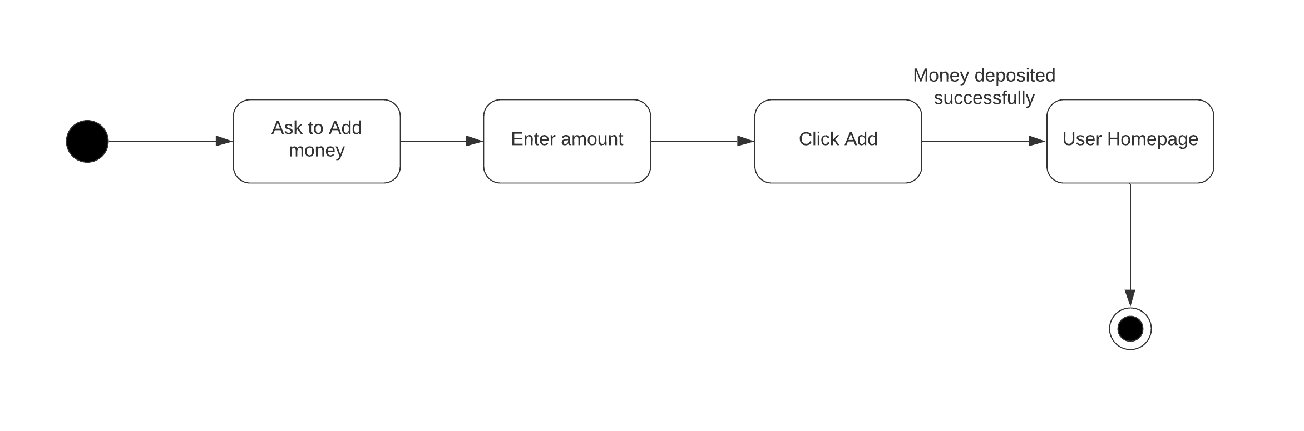

**Withdraw:**

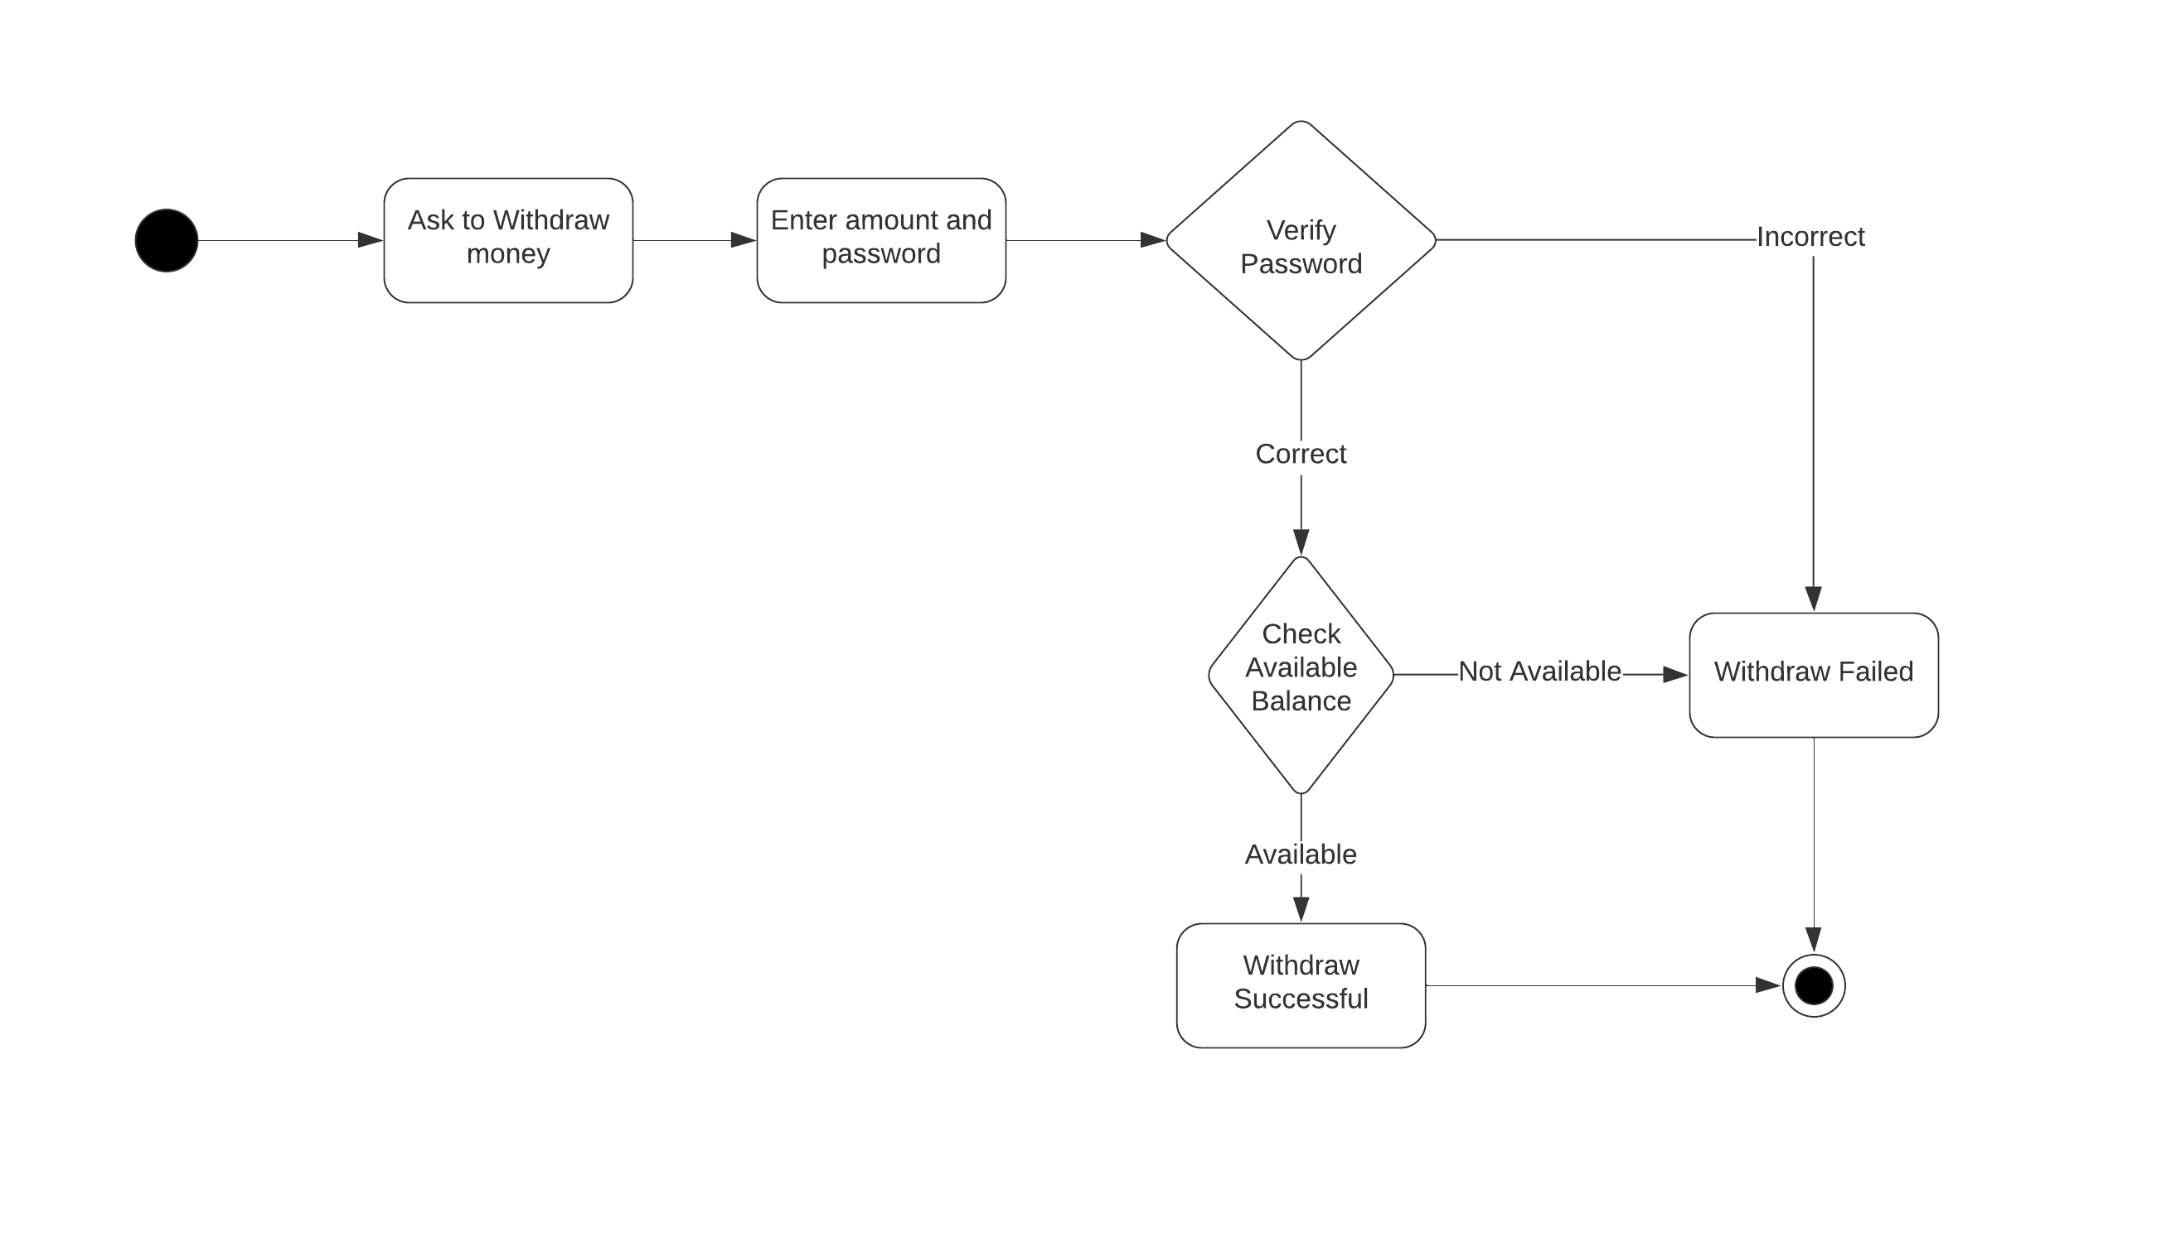

**Transfer:**

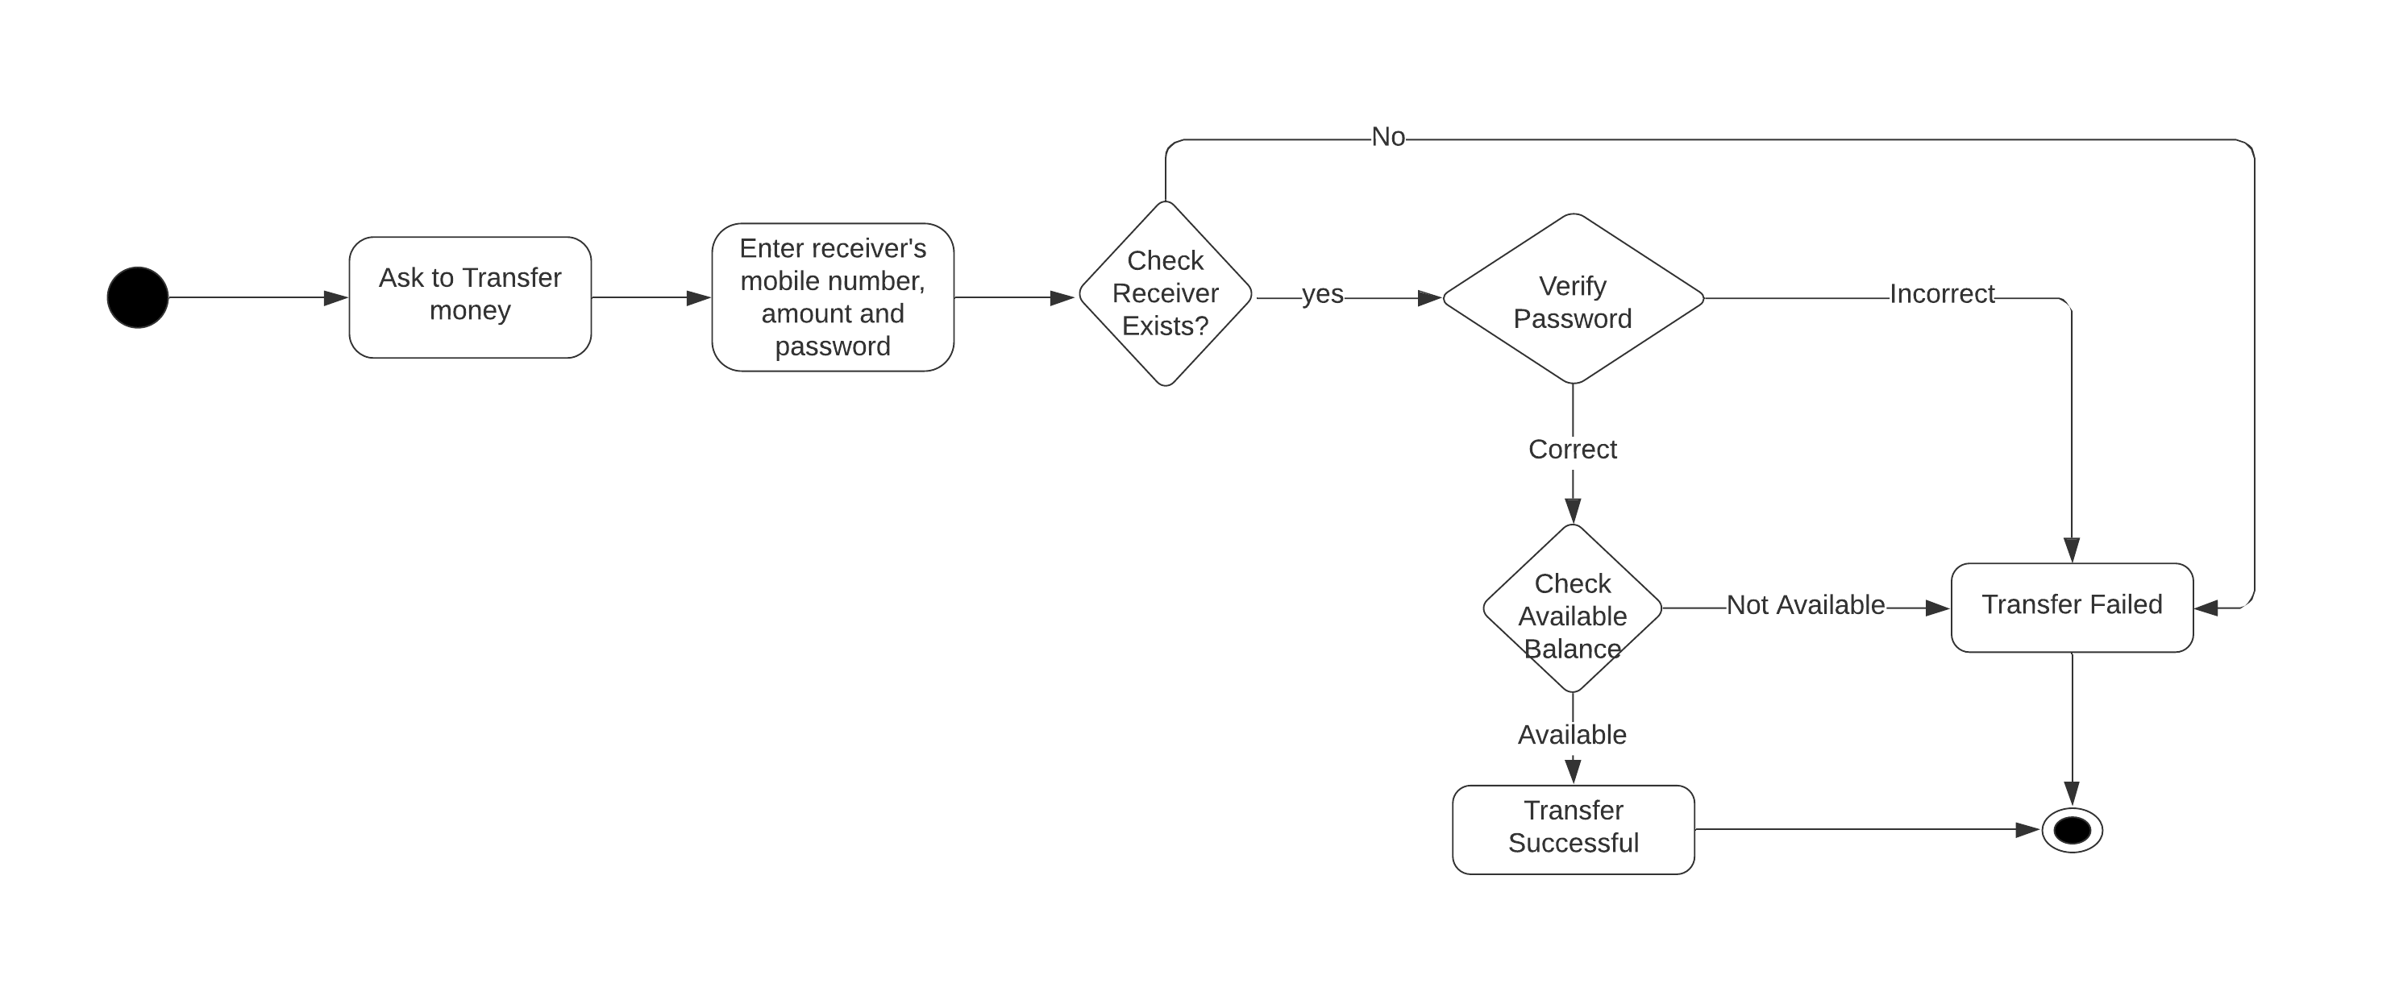

**Print Transactions:**

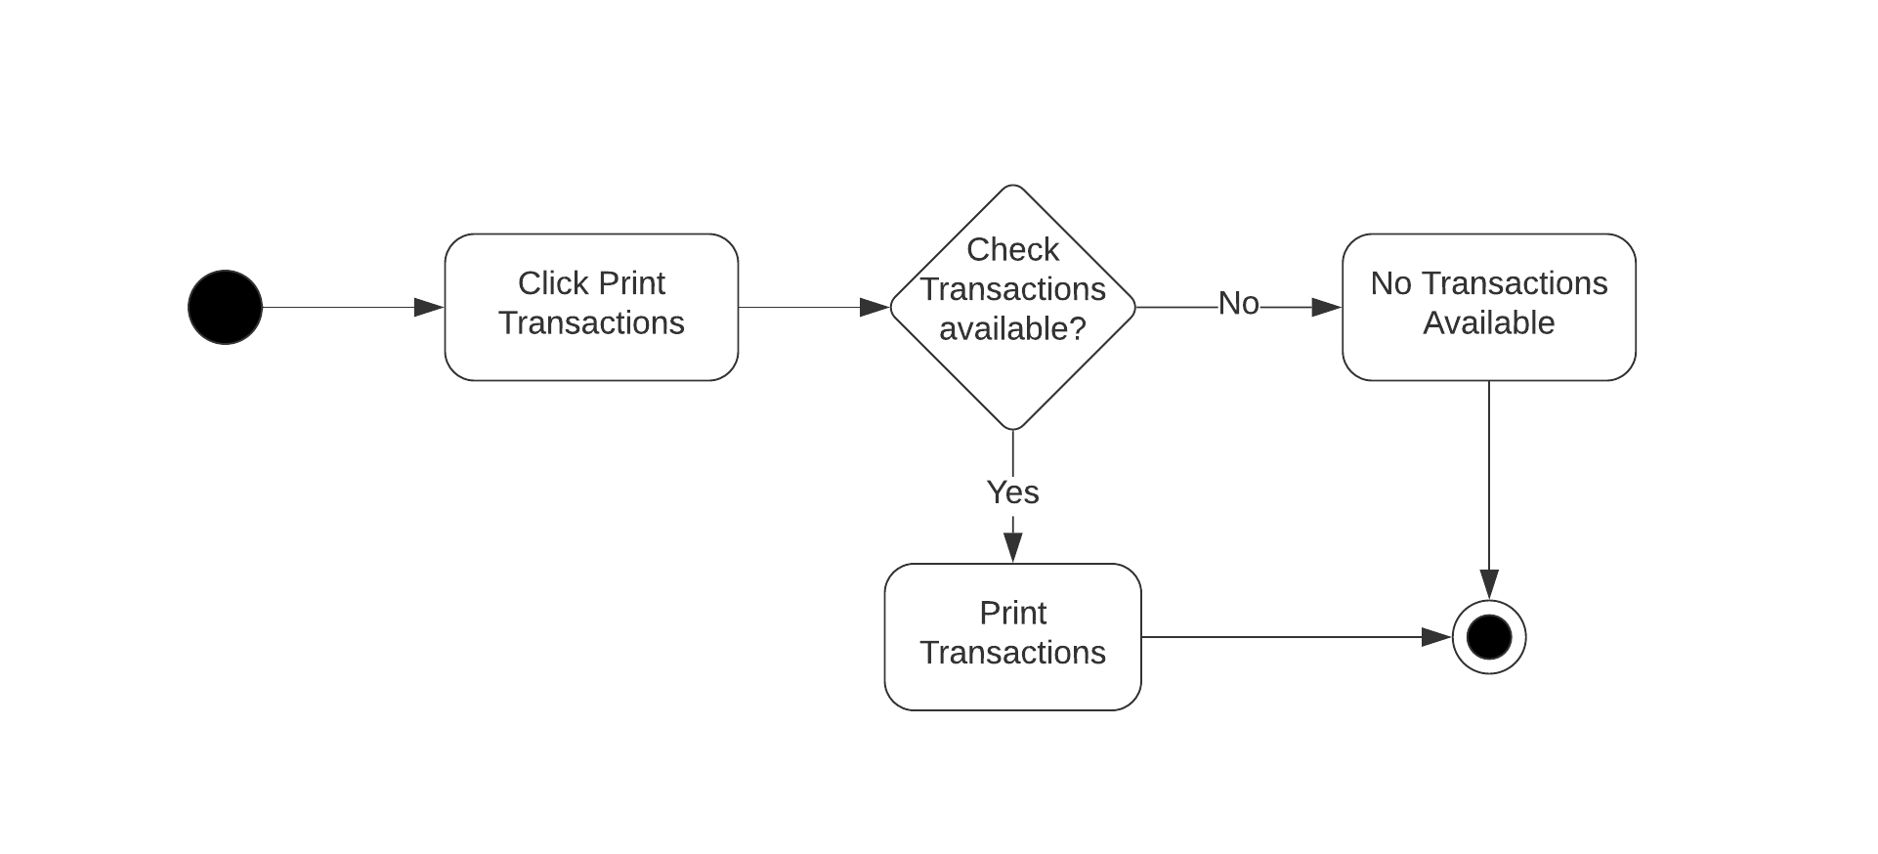

**Sequence Diagrams:**

**Registration:**

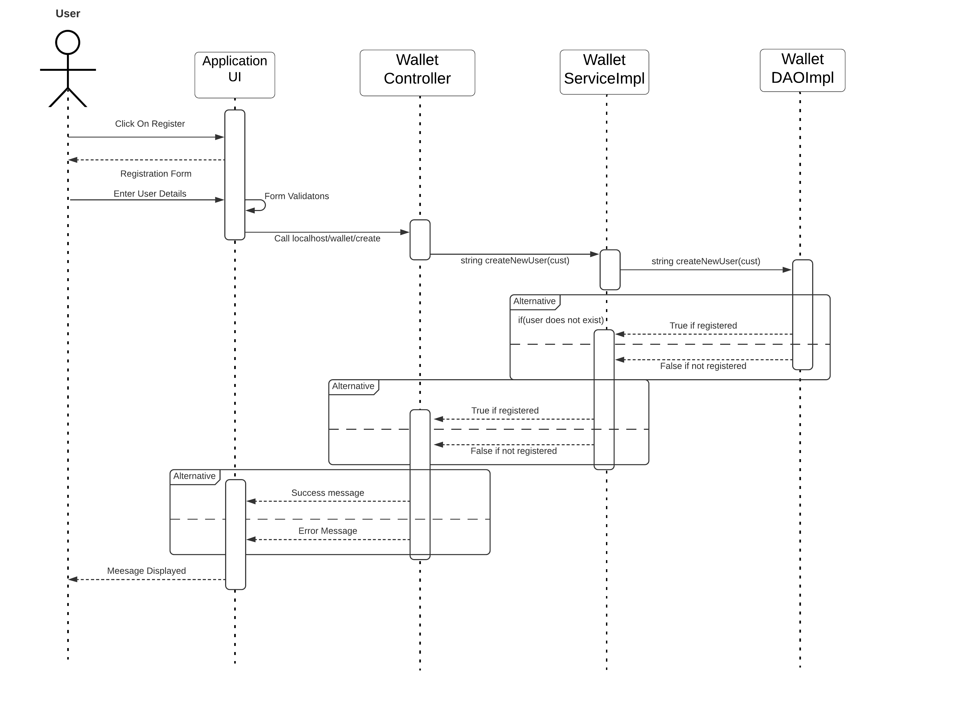

**Login:**

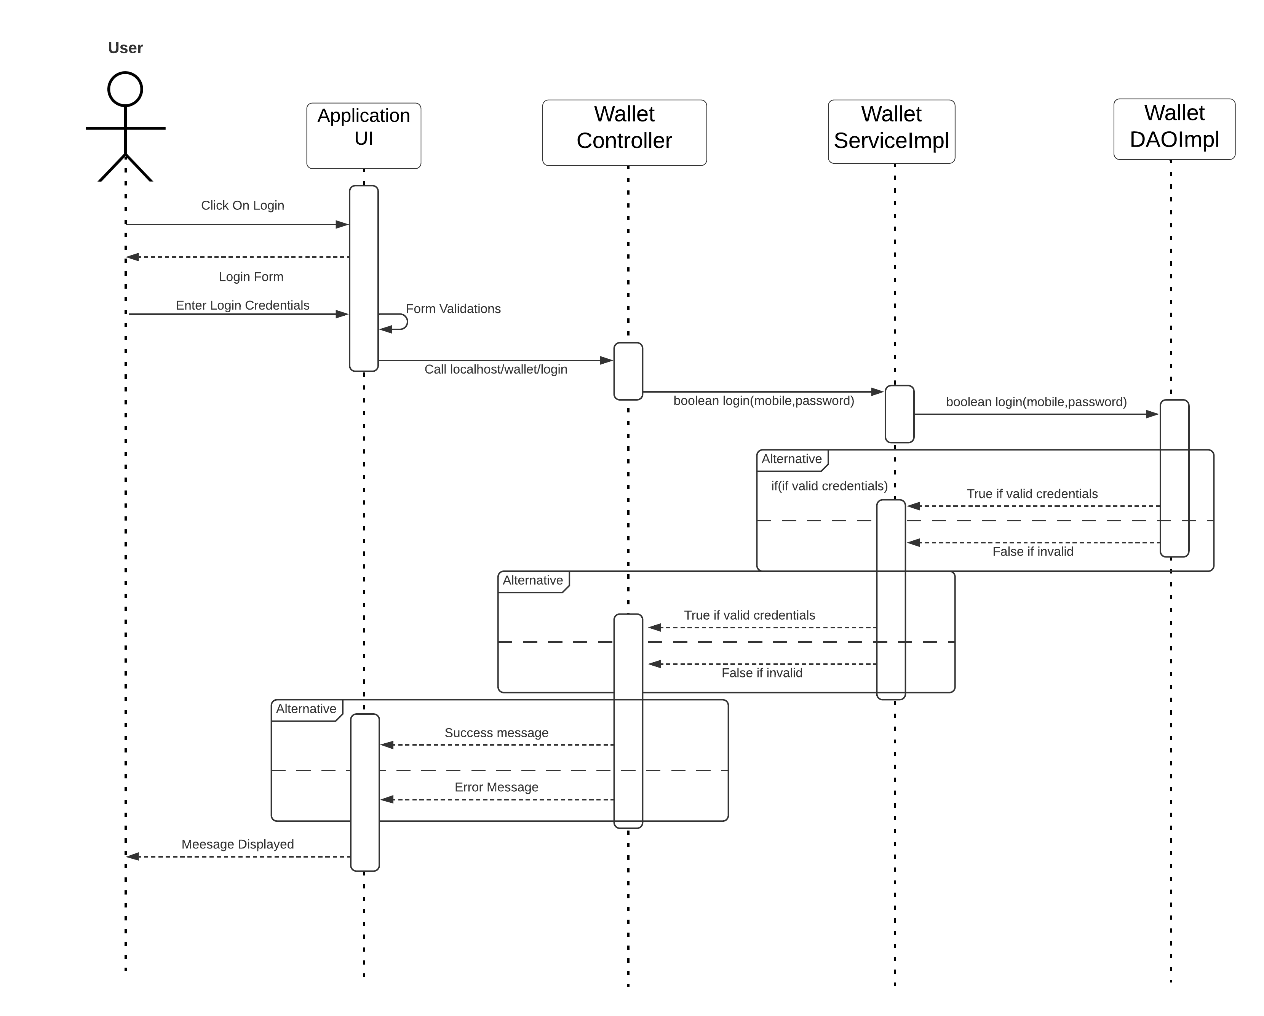

**Deposit:**

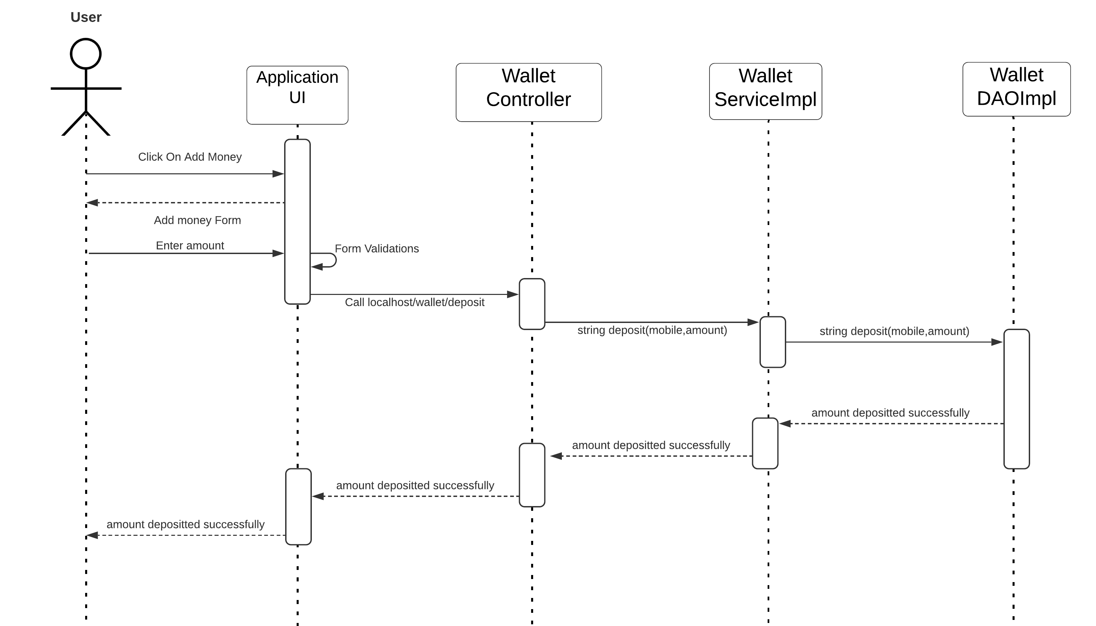

**Print Transactions:**

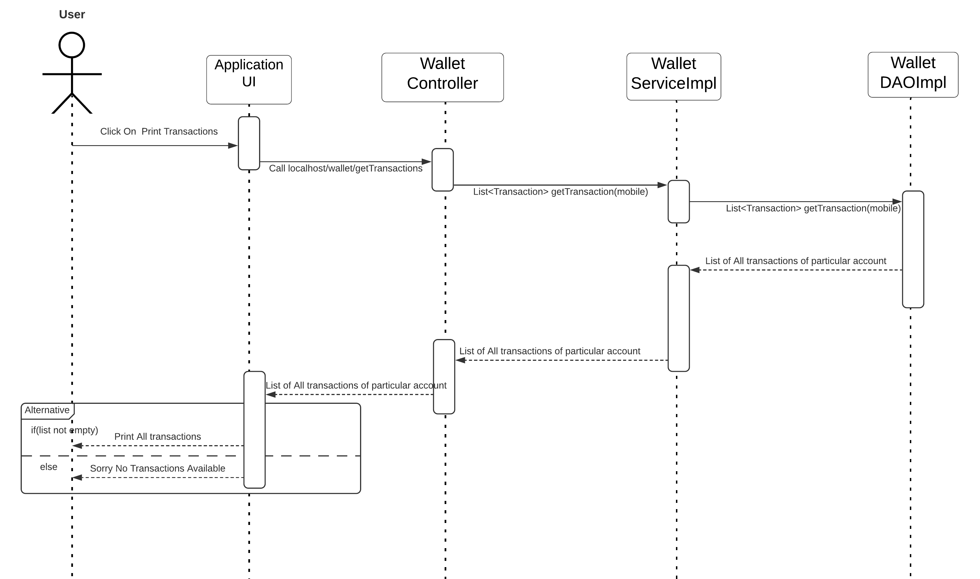

**Withdraw:**

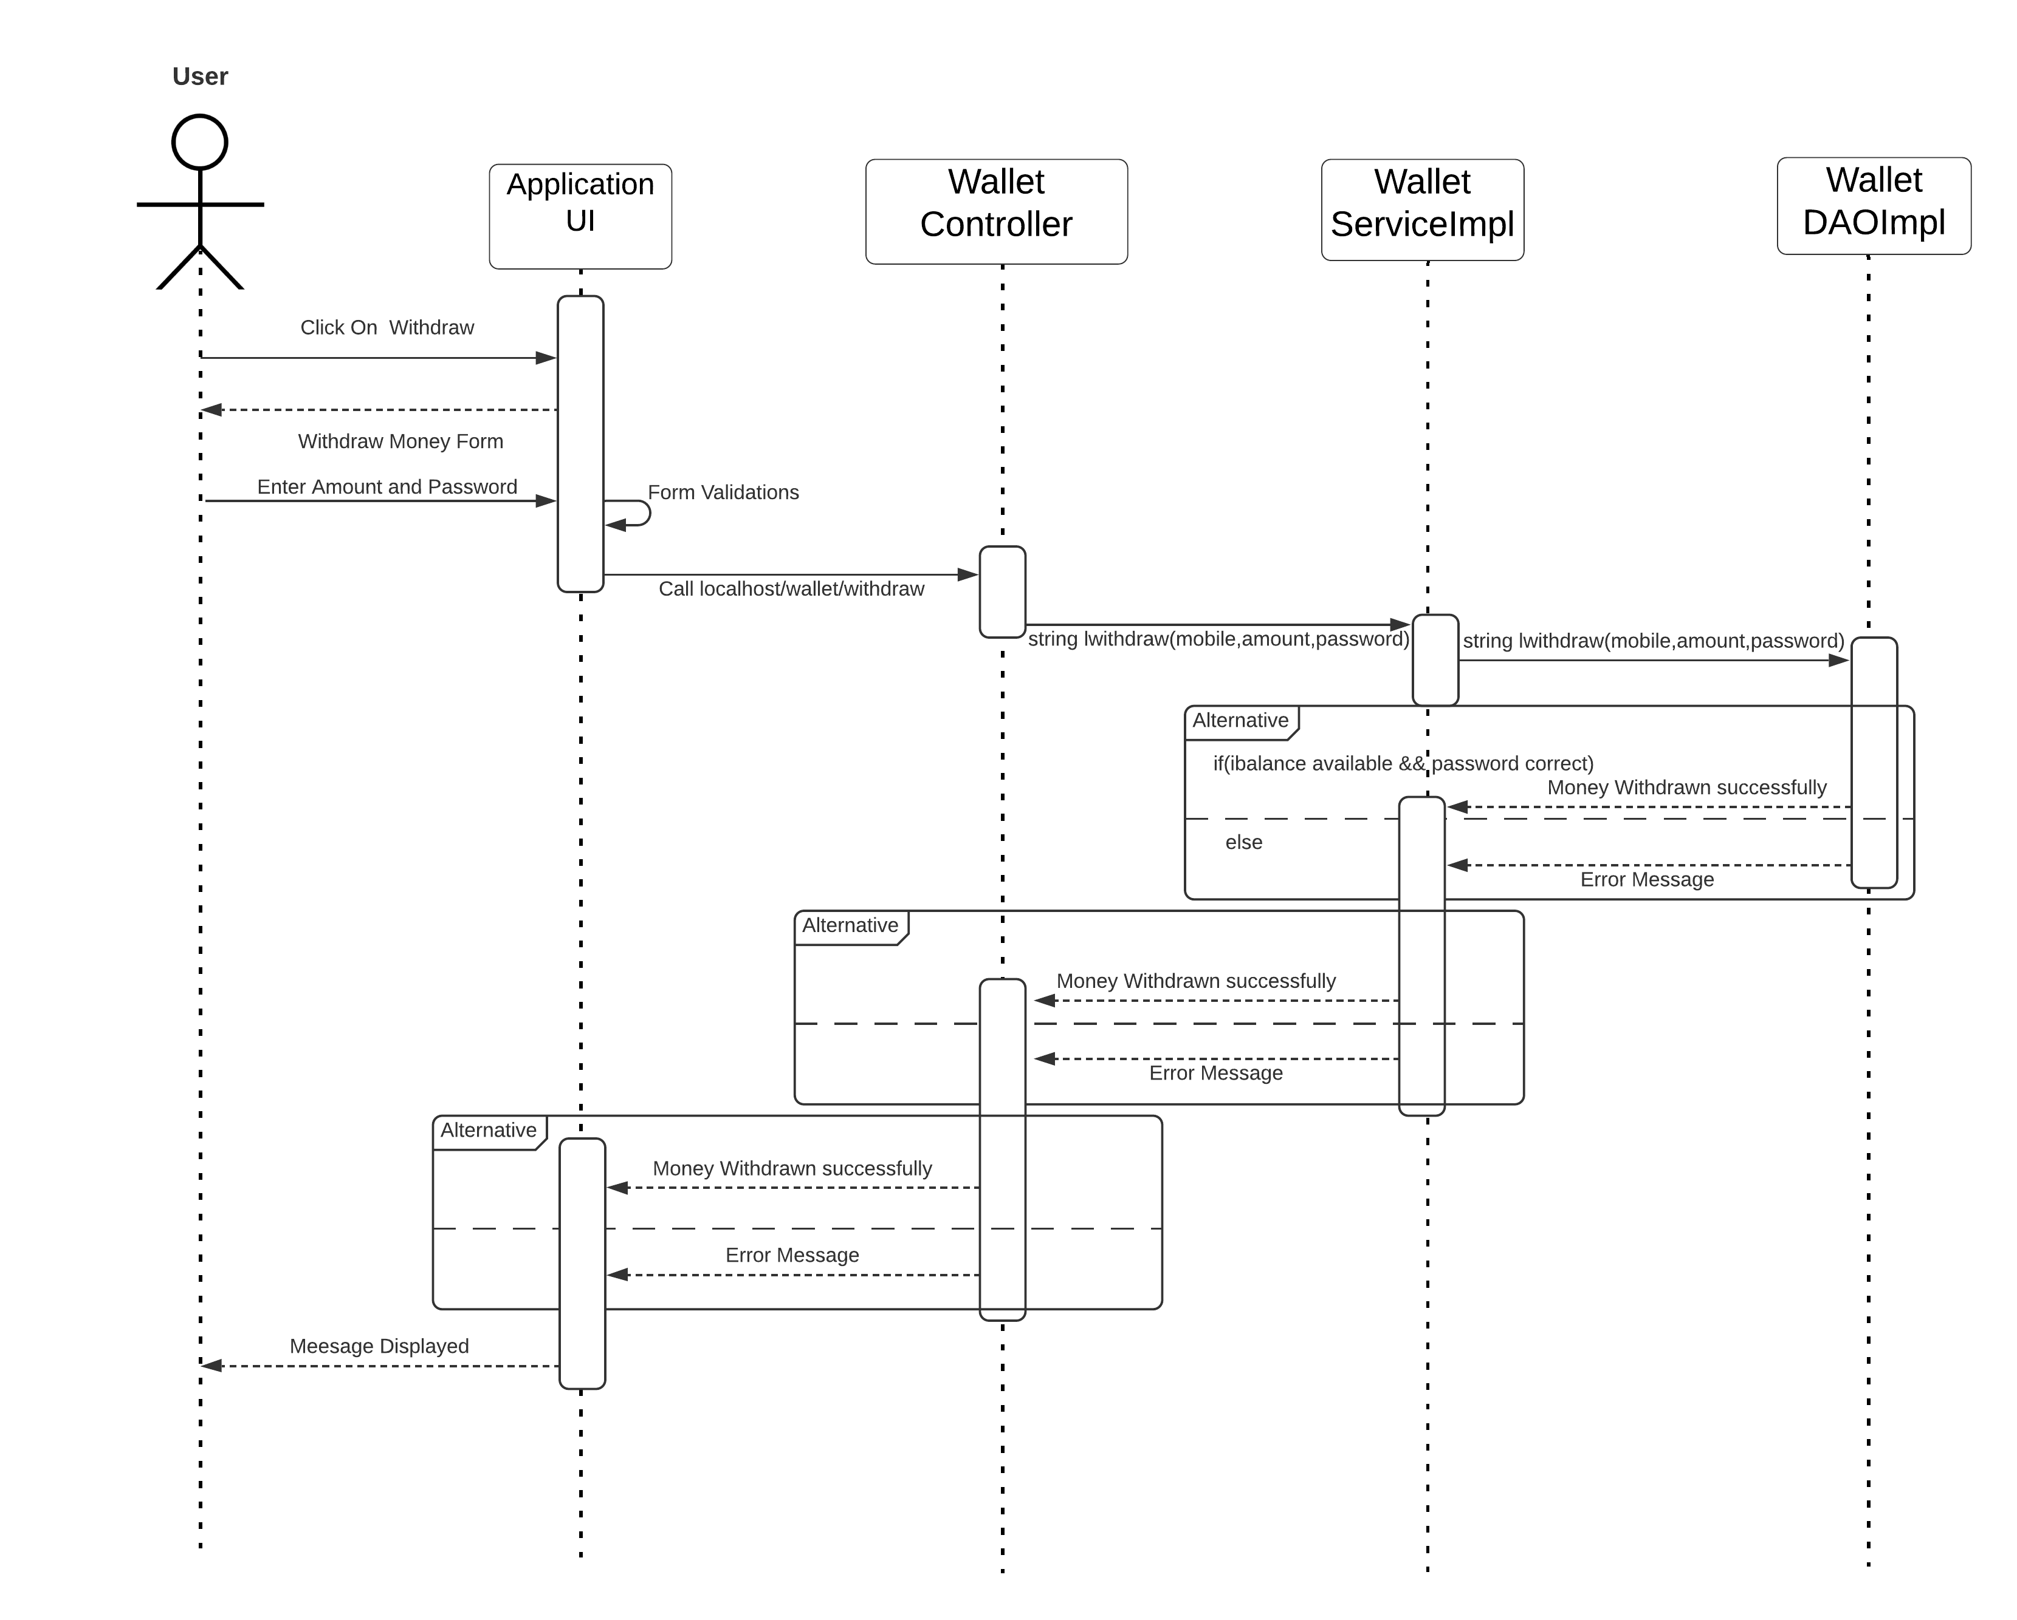

**Transfer:**

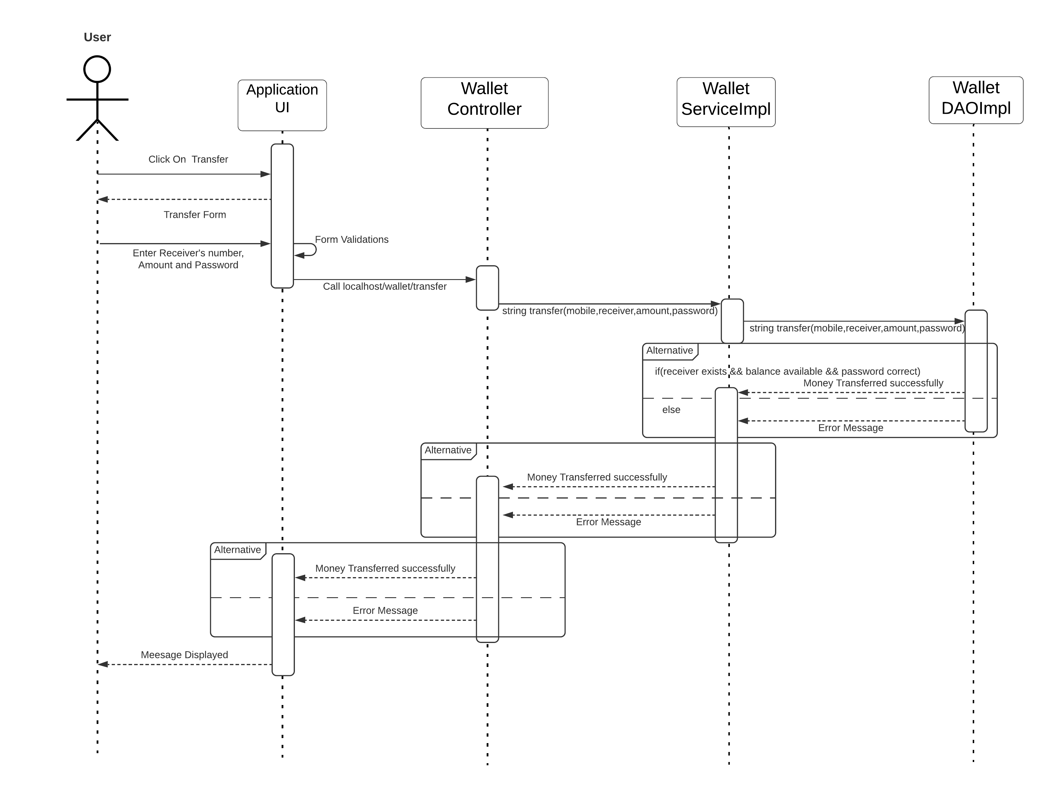

**Wireframes**:

**Register:**

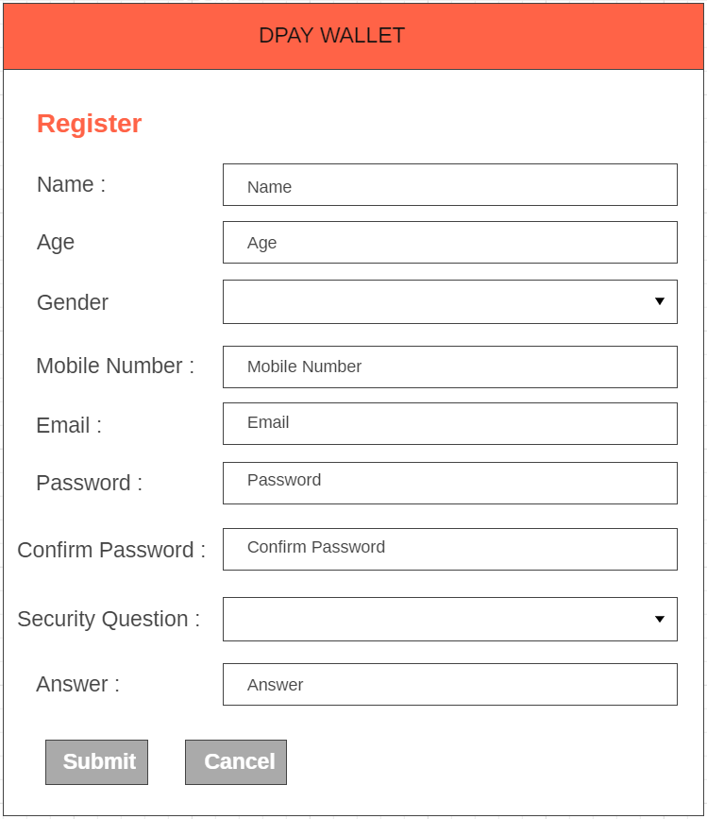

**Login:**

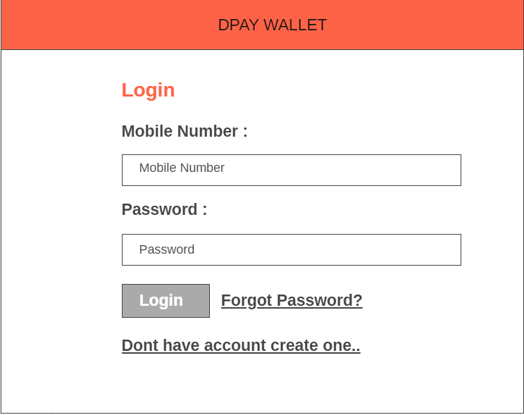

**Deposit:**

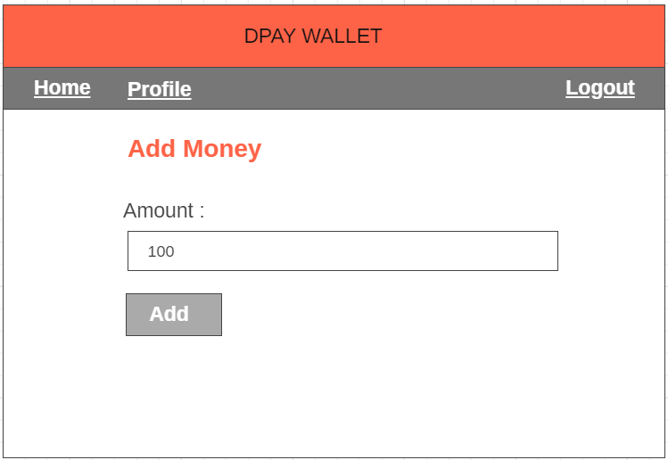

**Withdraw:**

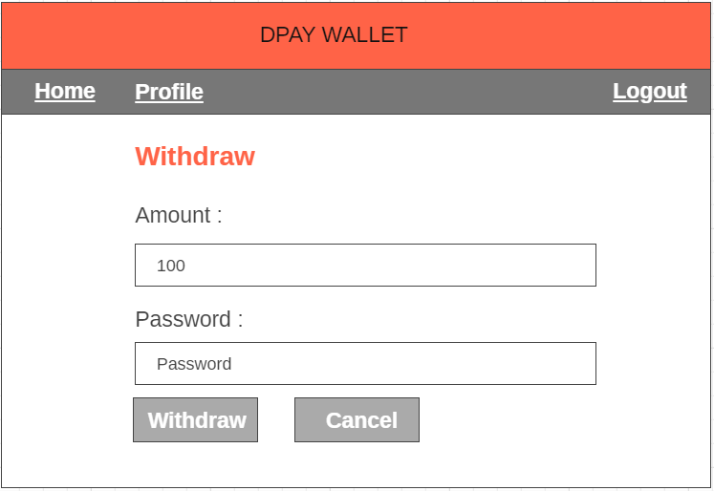

**Balance:**

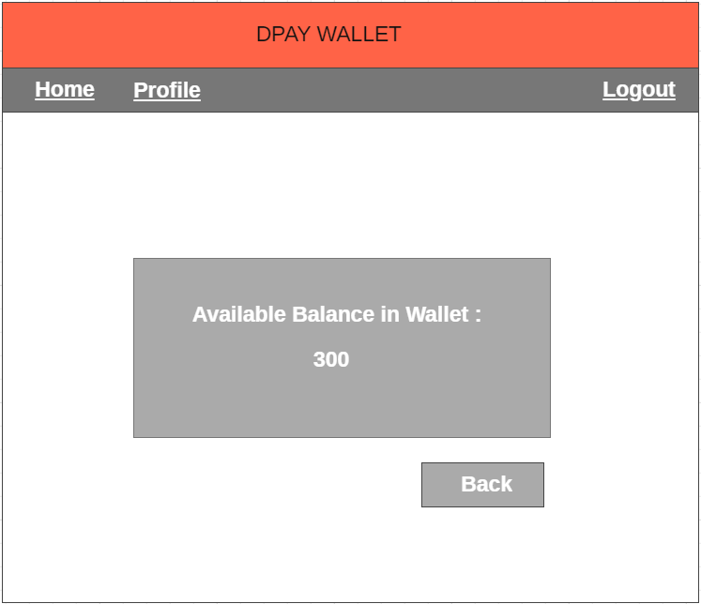

**Transfer:**

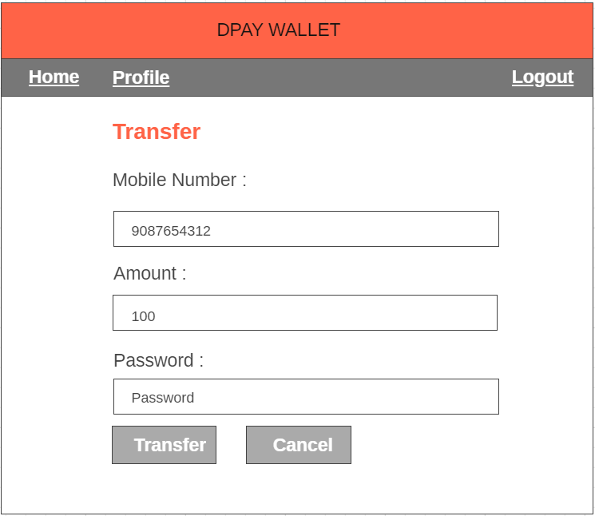

**Print Transactions:**

